Magnetic Sea puzzle  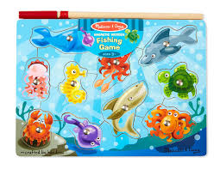  Basic Level  Ages: Pre-k through- 4th grade | Pieces included in visuals  Rules for game  - Place all the pieces to the game on the table  - With a peer and student have them take turns putting the pieces in the puzzle  - Have them label what animal they put in the puzzle using the “I put the ____ ____ in the puzzle”  - Play until all the pieces are back in the puzzle  Additional Tips and Ideas  - If a student wants a certain piece have them use the “I want the ___ ____ please”  - Label the animals  - Ask for certain colors of animals  - Provide fill in the blank or “WH” questions and have the student answers  - Have peers ask for an animal and see if the student can identify that animal and hand to the peer  - Count all the animals

